6.62: a)
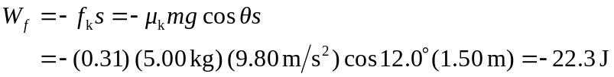
(keeping an extra figure) b)
c) The normal force does no work. d) 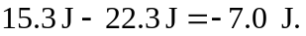
e) and so 

